Connor Johnson

Homework 7

3. a)

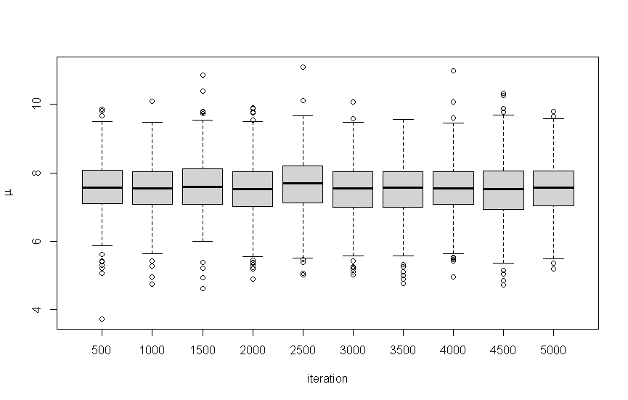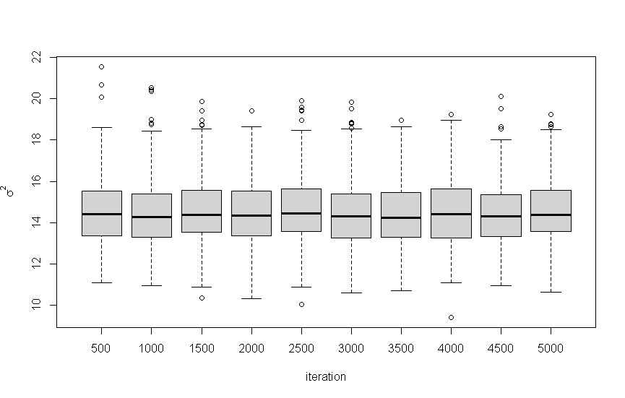

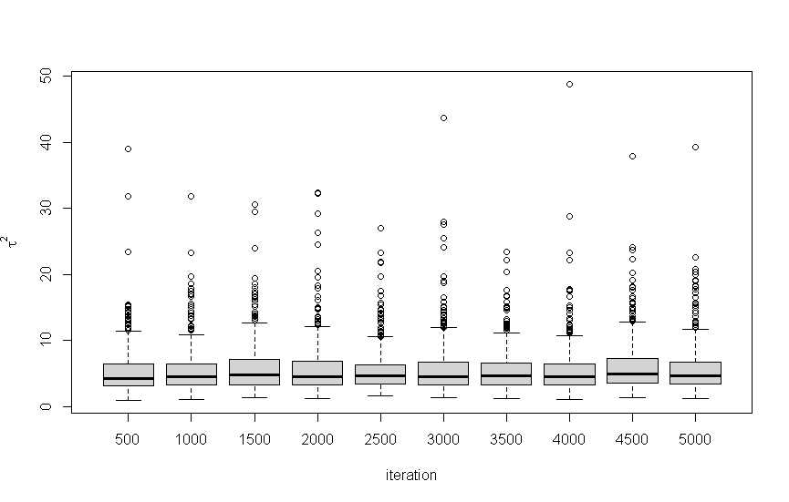

All three plots show it is stationary because the values don’t change much as iterations increase.

var1 var2 var3

4177.592 4738.887 3618.370

The effective sizes are shown above and are all greater than 1000.

b)

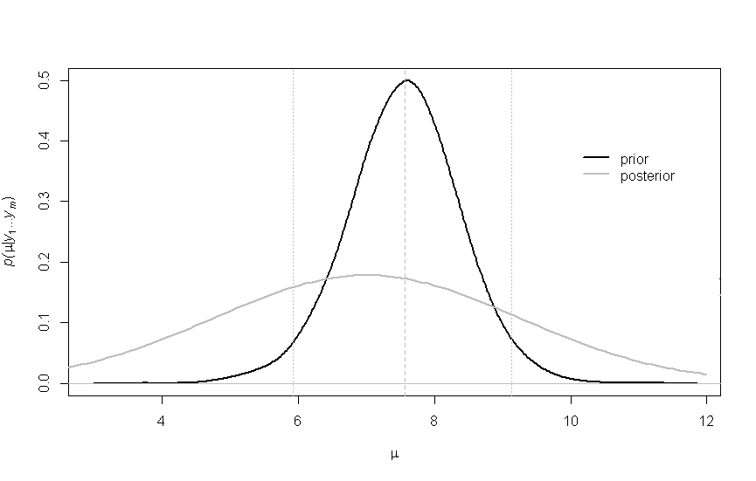

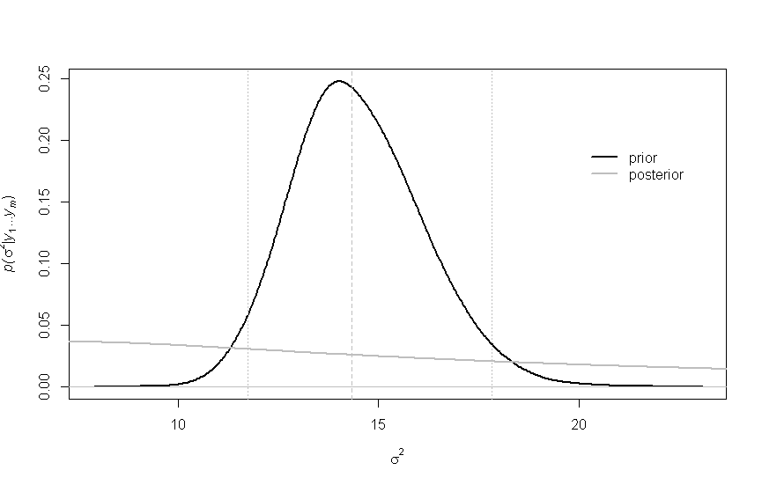

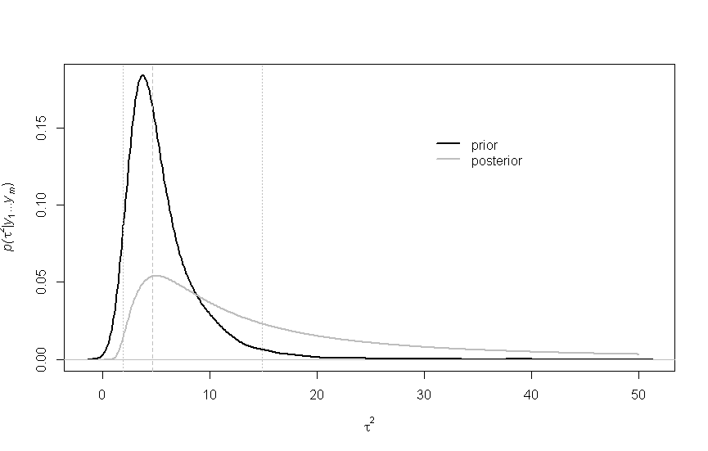

The prior estimates for tau and mu were pretty accurate, but the estimate for sigma was very far from accurate.

2.5% 50% 97.5%

[1,] 5.914609 7.565225 9.127841

[2,] 11.732720 14.343583 17.821712

[3,] 1.905460 4.617251 14.897491

These are the means and 95% confidence interval for mu, sigma^2, and tau^2 in that order

c)

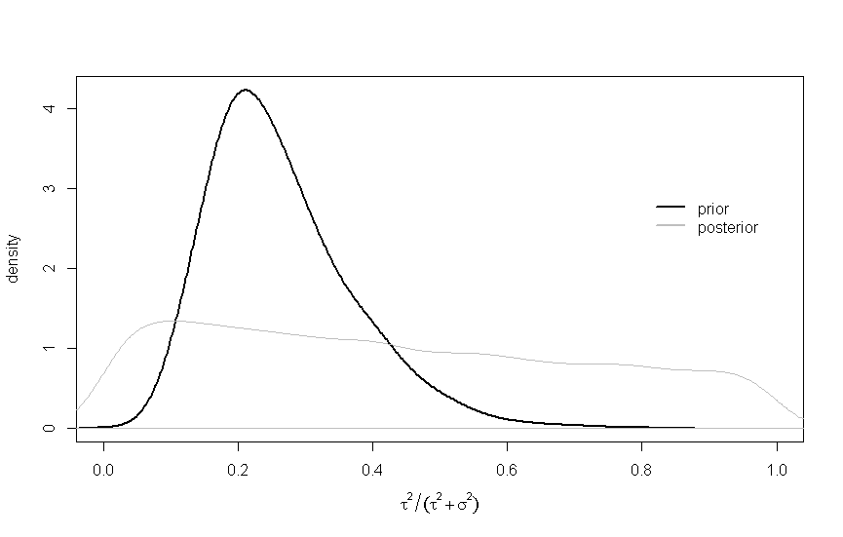

The value of R shows how much of the variance in the data is from between-group variance. The posterior shows that around 25% of the variance in the data is between-group.

d)

[1] 0.5104

This value is the probability that theta7 is less than theta6.

[1] 0.3068

This value is the probability that theta7 is less than all of the other theta values.

e)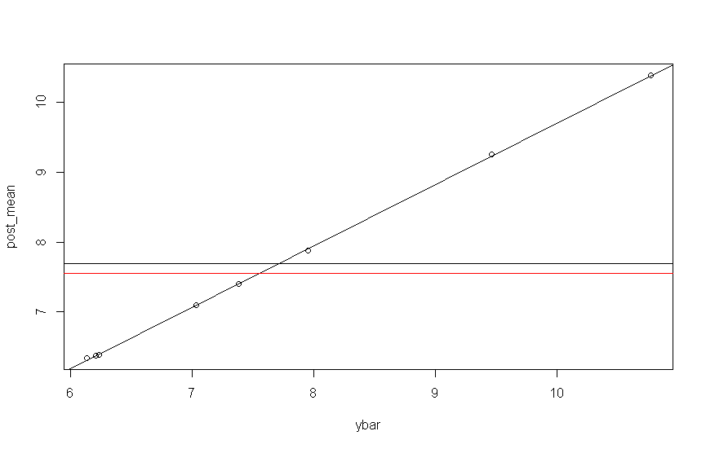

This graph shows there is a strong linear relationship between the means of each group and their respective posterior mean. The black line is the value of the mean of the entire sample. The red line tis the mean of the posterior means. The overall sample mean is slightly larger than the posterior means.